Dr. SACHIN SHA. S

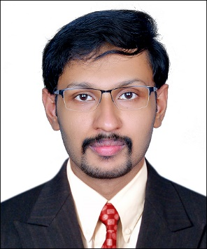

BDS, MDS (Conservative Dentistry & Endodontics)

Assistant Professor

Dept. of Conservative Dentistry & Endodontics

Sri Sankara Dental College,

Akathumuri, Varkala, Trivandrum

ACHIEVEMENTS

* Presented **Poster** on the topic “**Vertical root fractures and its management**” at the 31st IACDE and 24th IES National conference held at Kolkata from 11th to 13th of November 2016.
* A **short study** on the topic “MOLECULAR DOCKING: A TECHNIQUE FOR ELUCIDATING BINDING MECHANISM OF DRUGS ON MICROORGANISM- A BLENDED STUDY” was presented in 19th IACDE National PG Convention held at Gulbarga, Karnataka on February 2018. It was awarded **BEST PAPER**. The short study was **published** in International Journal Of Clinical and Diagnostic Research.

**PUBLICATIONS**

|  |  |  |  |
| --- | --- | --- | --- |
| NAME OF THE JOURNAL | TITLE | ISSUE AND VOLUME | DATE  OF PUBLICATION |
| International Journal Of Clinical And Diagnostic Research | Evaluation Of Antibacterial Efficacy Of Fortified Zinc Phosphate Cement With Herbal Extracts- A Molecular Docking Study | Issue: 6  Vol: 6 | Nov-Dec 2018 |
| International Journal Of Current Research | An In Vitro Comparison Of Compressive Strength And Microhardness Of Light Activated Bulk-Fill Composite And Newer Bulk Fill. | Issue: 4  Vol: 11 | April 2019 |
| ENDODONTOLOGY | In silico evaluation of the efficacies of two different  medicaments against Enterococcus faecalis. | Issue: 1  Vol: 31 | Jan-June 2019 |
| International Journal Of Current Research | The Disinfection Methods Of Alginate Impressions | Issue: 4  Vol: 11 | April 2019 |