**Department of Oral Medicine and Radiology**

1. **Name:** Dr. Deena.C.Thomas
2. **Photo:**

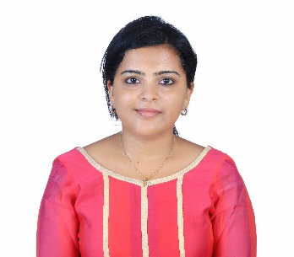

1. **Qualification:**

#### Bachelor of Dental Surgery

2008-2014

Sree Mookambika Institute of Dental Sciences,

Kulasekharam, Tamil Nadu

Under The Tamil Nadu Dr. M.G.R Medical University, Chennai, India.

**Masters in Oral Medicine and Maxillofacial Radiology** 2014-2017

PMS College of Dental Sciences and Research, Vattappara, Trivandrum

Under Kerala University of Health Sciences,T hrissur

1. **Designation:**

Assistant Professor

Department of Oral Medicine and Radiology,

Sri Sankara Dental College, Varkala, Kerala.

1. **Additional qualification:**

Certified course in Cone Beam Computed Tomography (CBCT) from Manipal University

#### List of publications:

#### International Publications

* 1. **Comparison of The Length of Styloid Process in Panoramic Radiographs to Computed Tomography as The Gold Standard.** Journal of pharmacy and Bioallied science.2022;14:S369-72.
  2. **The influence of stress in modulating the relationship between coronavirusdisease-2019 disease and sleep quality.** Journal of Pharmacy and Bioallied science. 2022;14: S415-9.
  3. **Pregnancy: general and oral considerations**. International journal of clinical and diagnostic research. 2020;8(1):111
  4. **Cameriere’s and Demirjian’s methods of age estimation among children in Kerala.** Clinics and practice 2018; 8:991:28-30.

#### National and state publications

1. **Moringa Oleifera: The natural herbal plant in Dentistry.** Journal of IDA Trivandrum Branch 2021;11(2):56-58
2. **Cone beam computed Tomography: Clairvoyance to Stomatologist.** Impressions Journal of IDA Attingal Branch 2018;8(1):19-22.
3. **Aloevera the herbal product in Dentistry**. Journal of IDA Attingal Branch,Vol 2018;8(2)43-45
4. **Fibrolipoma on the alveolar ridge-A case report.** Journal of IDA Trivandrum Branch 2017; 7:18-21.
5. **Plemorphic adenoma: An usual presentation on upper lip-A case report**. Journal of Indian Academy Oral Medicine Radiology 2017;29;217-9.