**DEPARTMENT OF ORAL MEDICINE AND RADIOLOGY**

1.**Name:** Dr. NITHIN. V. S

2.**Passport size photo**

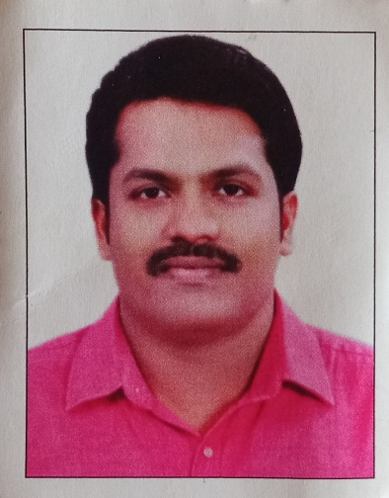

3.

|  |  |  |
| --- | --- | --- |
| **Qualification** | **College& University** | **Year** |
| BDS | SREE MOOKAMBIKA INSTITUTE OF DENTAL SCIENCES, KULASEKHARAM.  THE TAMILNADU Dr. MGR MEDICAL UNIVERSITY, CHENNAI. | 2009 |
| MDS  ORAL MEDICINE AND RADIOLOGY | PMS COLLEGE OF DENTAL SCIENCE AND RESEARCH, TRIVANDRUM.  KERALA UNIVERSITY OF HEALTH SCIENCES,  THRISSUR. | 2014 |

4.**Designation**

Associate Professor

Department of Oral Medicine and Radiology

Sri Sankara Dental College, Varkala, Kerala, India

**5.List of Publications:**

#### **International Publications**

1. **Curcumin the Miracle Herbal Drug in Dentistry.** International Journal of Science and Research 2018;7(5):1285-1287.
2. **Evaluation of the incidence and recovery of neurosensory deficiencies in patients undergoing major and minor surgeries in maxillofacial region.** Research Journal of Pharmaceutical, Biological and Chemical Sciences 2018;9(5):469-477.
3. **Pregnancy: General and oral considerations.** International Journal of Clinical and Diagnostic Research 2020;8(1):1-13.

#### **National and State Publications**

1. **Prevalence of Geographic tongue in patients attending a Dental College in South Kerala**. Trivandrum Dental Journal 2013;4(2):50-51.
2. **Lycopene and its applications in Dentistry**. Impressions Journal of IDA Attingal Branch 2015;1(1)31-32.
3. **Cone beam computed Tomography: Clairvoyance to Stomatologist.** Impressions Journal of IDA Attingal Branch 2018;8(1):19-22.
4. **Aloevera the herbal product in Dentistry**. Impressions Journal of IDA Attingal Branch 2018;8(2):43-45.
5. **Moringa Oleifera: The Natural Herbal Plant in Dentistry.** Trivandrum Dental Journal 2021;11(2):56-58.
6. **Recent Advancements in Oral Precancer Diagnosis.** Trivandrum Dental Journal 2021;11(3):86-91.