DEPARTMENT OF PERIODONTICS

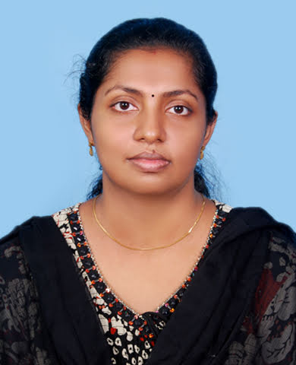

**Name:** Dr Aswathy S

**Qualification**: MDS

**Designation:** Reader

**Additional qualification, awards, achievements**:

**List of publications:**

|  |  |  |
| --- | --- | --- |
| **S.No.** | **Title of the Articles** | **Journal Details** |
| 1. | Radiographic techniques – an overview. | Journal of Society of Periodontologists.2013; 7[2]:65-67 |
| 2. | Periodontal diagnosis-where do we stand now? | International Journal of Women’s Dental Council.2015; 3[2]: 57-59 |
| 3. | Horizontal ridge augmentation – An overview. | Annals of dental speciality.2016; 4[2]: |
| 4 | What’s new about implants? Ligaplans. | Journal of Indian Dental Association, Kochi Branch. 2019;1:3 |
| 5 | Evaluation of correlation between sleep hours, sleep quality and salivary levels of 8-Hydroxy – 2- deoxyguanosine in chronic periodontitis patients – An observational study. | International Journal of Scientific Research.2020; 9:10 |
| 6 | Evaluation of salivary hepatocyte growth factor levels in chronic periodontitis patients before and after non-surgical periodontal treatment. | International Journal of Scientific Research.2020; 9: 8-10. |
| 7 | Periodontal vaccine: a new adjunct in periodontal therapy.. | International Journal Dental and Medical Sciences Research. 2020; 3(1):01-05 |
| 8 | Yes! Oxidative stress may be a risk factor for chronic Periodontitis patients. | Global Journal for Research Analysis.2020; 9[12]:26-28 |
| 9 | Role of Epigenetics in periodontal therapy. | Happenings -A KUHS Publication on Recent Advances.2021; 4: 48-50. |
| 10 | Nanodentistry : a review | Journal of Indian dental association- Kochi;2021:3[1]:23-6 |
| 11 | Marine based biomaterial : a marvel in periodontal regeneration- a review | Advanced dental journal 2023,5[1]:24-34 |