DEPARTMENT OF PERIODONTICS

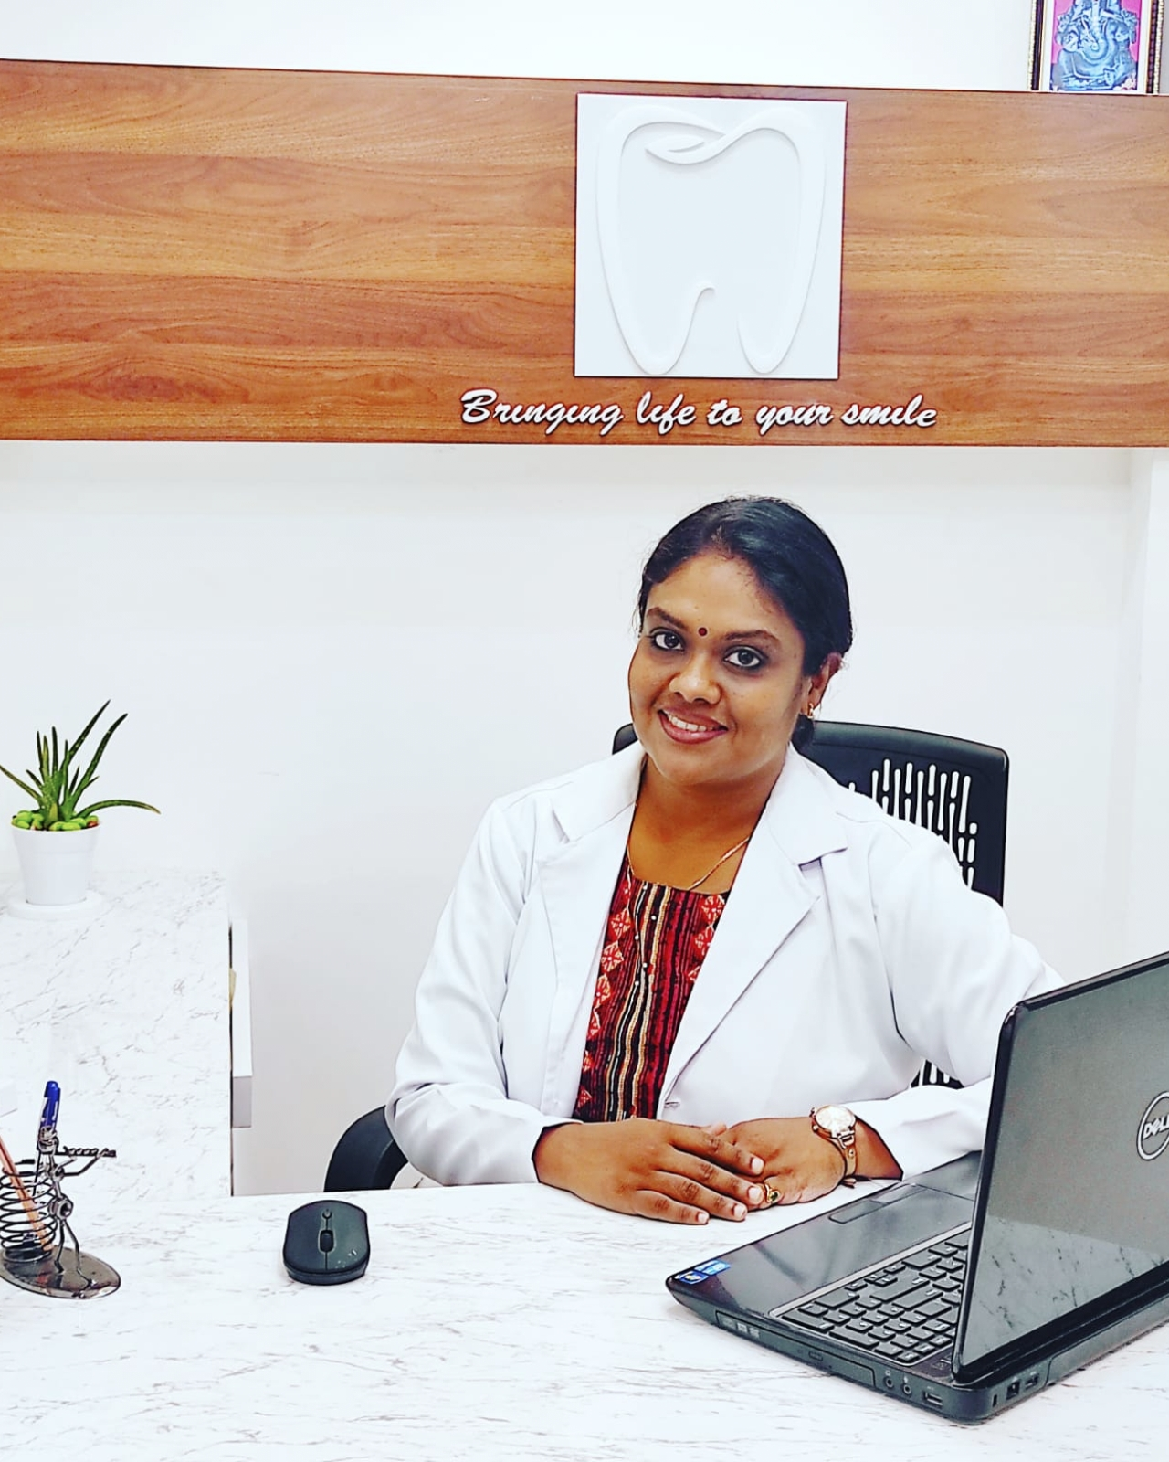

**Name**: Dr Nita Syam

**Qualification**: MDS

**Designation**: Reader

**Additional qualification, awards** :

**List of publications** :

|  |  |  |
| --- | --- | --- |
| **Serial Number** | **Title of the Article** | **Journal Details** |
| 1. | Salivary -8-hydroxydeoxy guanosine – a valuable indicator for oxidative DNA damage in periodontal disease. | The Saudi Journal for Dental Research 2015;6:15-20. |
| 2. | Management of ankyloglossia using diode laser- a case report. | International journal of current research 2017;9:57243-5. |
| 3. | Nanoperiodontics. | Impressions – Journal of IDA Attingal Branch 2017;7:17-8. |
| 4. | LANAP – a ray of hope in periodontal therapy. | Impressions – Journal of IDA Attingal Branch 2017;7:54-6. |
| 5. | Periodontics and atherosclerotic vascular disease. | Andhra Pradesh Dental Journal 2012;5:531-7. |
| 6. | Photodynamic therapy in periodontic and periimplantitis- an unique promising light therapy. | Trivandrum Dental Journal 2012;32. |
| 7. | Periodontal microsurgery – better vision to perfection. | Journal of the Society of Periodontist and Implantologists of Kerala 2015;.82:54-7. |
| 8 | Nano dentistry: a review | Journal of Indian Dental Association - Kochi, 2021 ;5(1): 24 - 34 |