**SRI SANKARA DENTAL COLLEGE, AKATHUMURI**

**DEPARTMENT OF PROSTHODONTICS**

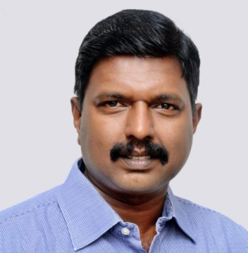

**Name:** Dr Pradeep C Dathan

**Qualification:** MDS Prosthodontics

**Designation:** Professor and Head of the Department

**Additional Qualification:** Post doctoral fellowship

**Awards:**

1. Best editor National award winner in 2017 for editor of Indian dental association- Attingal branch journal.
2. Best editor National award runner up 2018 as editor of Indian dental association- Attingal branch journal.
3. Best paper award in 36th Indian Prosthodontic Society National conference, New Delhi, 2007
4. Best paper award in 37th Indian Prosthodontic Society National conference,Thrissur, 2009

**Achievements:**

1. Editor of Indian dental association- Attingal branch journal
2. President IDA Attingal branch

**List of publications**

1. Veneering with porcelain Laminates. IDA Kunnamkulam. 2003; 14-15
2. Ocular Prosthesis. A case report. JIDA. Attingal.2007:5; 25-26
3. Prosthetic rehabilitation of prosthetic limb with RTV silicon using prosthodontic clinical and laboratory technique- A case report. Journal of clinical and diagnostic research. 2016:10(8);35-37
4. Rehabilitation of acquired maxillary defects. KDJ. 2012:35(4);385-386
5. PALM-S: A dental material teaching aid . KDJ 2012:35(3); 333-334
6. Quorum quenching- a novel strategy to eradicate biofilms. JSPIK.2011:5(2);66-67
7. Titanium dioxide and calcium sulphate composite. A novel bone grafting material. Trends biomaterials artificial organs. 2014: 28(1); 1-7
8. Some factors that affect dental implant treatment. JIDA Attingal, March 2017: 7(1); 7-10
9. Esthetic rehabilitation of periodontally compromised dentition using a combination of gumfit and cusil denture. JIDA Attingal, March 2017: 7(1); 29-31
10. Direct bonded FPD. . JIDA Attingal, June 2017: 7(2); 63-65
11. A protean approach for rehabilitation of partially edentulous patient- case report. . JIDA Attingal, June 2017: 7(2); 69-71
12. Polishing of newer ceramics. JIDA Attingal, September 2017: 7(3); 83-85
13. Temporomandibular disorders (Part- 2)- Diagnosis diseases. JIDA Attingal, September 2017: 7(3); 95-96
14. Prosthetic rehabilitation of partially edentulous maxilla with precision attachment. Journal of IDA Attingal Branch, March 2019; 9(1), pp.32-34.
15. Surgical Stents - A Guide For Precise Implant Placement. Journal of IDA Attingal Branch, March 2019; 9(1), pp 11-14.
16. Telescopic denture - a case report. Journal of IDA Attingal Branch, March 2019; 9(1), pp. 29-31.
17. All you need to know about CAD-CAM. . Journal of IDA Attingal Branch, March 2019; 9(1), pp 15-18
18. Maxillary obturator prosthesis for rehabilitation after maxillectomy: A clinical case series. Journal of IDA Attingal Branch, June 2018; 8(2), pp. 64- 66.
19. Cone beam computed tomography in Prosthodontics. . Journal of IDA Attingal Branch, June 2018; 8(2), pp 61-63
20. A Spick and Span Articulator: A Tee Off. Journal of IDA Attingal Branch, June 2019; 9(2), pp 57-58
21. Beading and boxing simplified. Journal of IDA Attingal Branch March 2020 ; 10(1), pp. 15-17
22. Implant retained auricular prosthesis with a modified hader bar: A case report. J Indian Prosthodont Soc, March 2013
23. The relevance of polishing acrylic dentures- An overview. Acta scientific dental sciences5.5(2021): 63-70
24. Prosthodontic significance of incisive papilla- An overview. Acta scientific dental sciences 5.6(2021)
25. Resins for CAD/CAM Denture. Acta scientific dental sciences April 2021; 5(4)
26. Welcome to the Profession of Dentistry-A Briefing for I BDS Students. Acta scientific dental sciences. June 2021; 5(5)
27. Know Covid-19 and Fight it - An Overview on the Pandemic. Acta scientific dental sciences. July 2021; 5(7)
28. Pomegranate uses in biomedicine: a review. Journal of survey in fisheries sciences.2023; 10(IS)96-116
29. “Sage Kashyapa- Master of dental anatomy and embryology”. Acta Scientific Dental Sciences 6.11(2022): 135-138
30. An insight into the structure, properties and applications of titanium, the magic metal. Trends Biomater. Artif. Organs, 36(2), 139-146 (2022)
31. Hardness of Dental Materials is an Essential Property that Determines the Life of Restorations- An Overview”. Acta Scientific Dental Sciences 6.12(2022): 129-134
32. Prosthetics- an exciting frontier. The cordial; pg 53-59
33. Digital impressions. Indian Dental Research and Review,April 2022:15(3); 6-10
34. “Acharya Sushruta- The Patron Saint of Dentistry”. Acta Scientific Dental Sciences 6.8(2022): 71-78
35. “Bone Grafts- A valuable substitute for replacing bony defects- A review”. Acta scientific dental sciences 6.4(2022): 42-53
36. “Group discussion in dental education has great potential- An overview”. Acta scientific dental sciences 6.10(2022): 115-120
37. “Evolution of dental science in ancient India”. Acta scientific dental sciences 6.1(2022)
38. “Role of objectives in Dental Education.” Acta scientific dental sciences 6.2(2022): 88-94
39. “Lecture Remains to be an effective method of teaching in dental education.” Acta scientific dental sciences 6.3(2022): 10-16

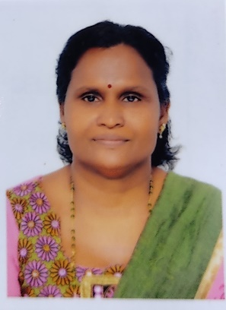**Name:** Dr Chandrathara T K

**Qualification:** MDS Prosthodontics

**Designation**: Professor

**Additional Qualification:**

**Awards:**

**Achievement:**

**List of publications**

1. Analysis of the stress distribution pattern of anatomic and non anatomic tooth forms on maxillary and mandibular edentulous ridges- a photoelastic study. Journal of biosciences and medicine 2020. Published on Jun 10 2020. Pg 113- 126 [15]
2. Comparative evaluation in different types of treatment on titanium alloy samples with or without gentramycin and its effect on biofilm. An in vitro study. International journal of preventive and clinical dental research (ISSN 2349-7319) 2019 vol 6 issue 4 pg 73-75 [7.5]
3. Comparative evaluation of biofilm formation among 3 differently treated surfaces on titanium samples along with gentamycin coating. International journal of oral care and research 2019 oct – dec vol 7 issue 4 pg 88 [7.5]
4. Comparative evaluation of biofilm formation among 3 differently treated surface on titanium samples. International journal of preventive and clinical dental research 2020 vol 7 issue 1 pg 8- 10 [7.5]
5. Minimal invasive techniques in porcelain laminate veneers JIDA ATTINGAL MARCH 2018; 8(1), pg 26-29. [5]
6. Conservative extra coronal restoration – porcelain laminate veneer BIDA IDA kochi pg 40-42[ 2.5].
7. All you need to know about CAD-CAM. JIDA Attingal march 19 vol 9 issue 1 pg 15-18[2.5]
8. Cone beam computer tomography in prosthodontics. JIDA Attingal june 2018vol 8 issue 2 pg 61-63[ 2.5]
9. A protean approach for rehabilitation of partially edentulous patient- case report. JIDA Attingal june 2017 vol 7issue 2 pg 69-71 [2.5]
10. Immediate extraction implant placement KDJ vol 34 no 3 july 2011 pg 328-331 [2.5]
11. A Simplified Feeding Appliance for An Infant With Cleft Palate. Journal of IDA Attingal Branch, March 2018; 8(1), pp.33-35
12. The relevance of polishing acrylic dentures- An overview. Acta scientific dental sciences5.5(2021): 63-70 [7.5]
13. Comparative evaluation of implant placement with conventional and digital surgical guide techniques- two case reports. Surgical science vol 13 Nov 2022.

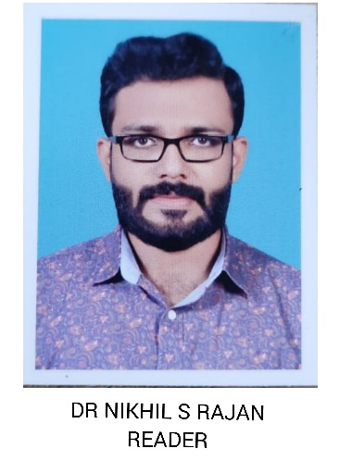**Name:** Dr Nikhil S Rajan

**Qualification:** MDS Prosthodontics

**Designation**: Associate Professor

**Additional Qualification:**

**Awards:**

1.Best Research Paper for the International Prosthodontic Conference Held in Dubai 2011

2.Had been selected for best Research paper at International conference of indian prosthodontics society held at Dubai on December 2012

**Achievement:**

**List of publications**

1. Prosthetic Rehabilitation of a Xerostomia patient with a mandibular split salivary reservoir denture . KDJ VOL 35 feb 2012

2. Aesthetic rehabilitation of a periodontally compromised dentition using a combination of Gum Fit & Cu-SIL denture. Journal of Indian dental association Attingal branch, impressions vol 17 no 1 march 2017

3.Evaluation of speech intelligibility of a Cleft palate patient with speech prosthesis before and after Palato-graphical analysis and prosthetic management. International journal of bio sciences and medicine 05(06)60-69 Jan 2017

4.Ambidexterity of immortal plant in dentistry . International journal of advanced research (IJAR) 7(4) 626-630

5.A comparative evaluation in different types of treatments on titanium alloy samples with or without gentamicin and its effect on biofilm: An in vitro studyINTERNATIONAL JOURNAL OF PREVENTIVE AND CLINICAL DENTAL RESEARCH(ISSN 2349-7319)Year2019  |  Volume : 6  |  Issue : 4  |  Page : 73-75

6. Short syndrome – A Bizarre Genetic Oddity ,( Accepted for publication ) International Journal of scientific research

7. A case control study to evaluate the prevalence of dental erosion in patients with gastroesophageal reflux disease ( Accepted for publication ) International Journal of Dental Science and Innovative Research

8. Comparative evaluation of biofilm formation among three differently treated surface on titanium samples. International journal of preventive and clinical dental research 2020 ,Volume7 issue 1 pages 8-10

9. A comparative evaluation in different types of treatments on titanium alloy samples with or without gentamicin and its effect on biofilm:An invitro study [pg.73] International Journal of Preventive and Clinical Dental Research (Int J Prev Clin Dent Res)2019 | October-December | Volume 6 | Issue 4

10. Prosthodontic significance of incisive papilla- an overview. Acta scientific dental sciences 5.6(2021)

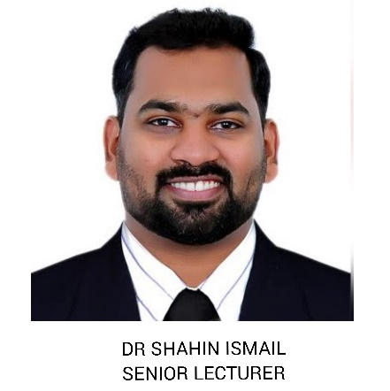**Name:** Dr Shahin Ismail

**Qualification:** MDS Prosthodontics

**Designation**: Associate Professor

**Additional Qualification:**

**Awards:**

1. Best paper award for Paper Presentation in IDA State Conference 2015, Alappuzha

**Achievement:**

1.Sub Editor “Panchajanya” magazine SSDC

**List of publications**

1. Putty index technique in for tripoding the cast. Journal of Prosthodontics 2017
2. A protean approach for rehabilitation of partially edentulous patient a case report. JIDA Attingal 2017
3. Direct bonded FPD- A case report. JIDA Attingal 2017
4. Telescopic denture - a case report. JIDA Attingal 2019
5. The relevance of polishing acrylic dentures- An overview. Acta scientific dental sciences5.5(2021): 63-70
6. Pomegranate uses in biomedicine: a review. Journal of survey in fisheries sciences.2023; 10(IS)96-116
7. An insight into the structure, properties and applications of titanium, the magic metal. Trends Biomater. Artif. Organs, 36(2), 139-146 (2022)
8. “Bone Grafts- A valuable substitute for replacing bony defects- A review”. Acta scientific dental sciences 6.4(2022): 42-53

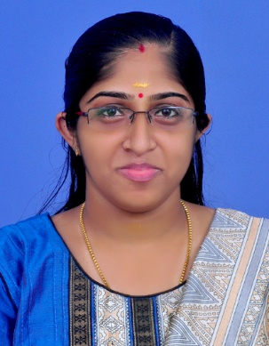**Name:** Dr Dhanya P Nampoothiri

**Qualification:** MDS Prosthodontics

**Designation**: Assistant Professor

**Additional Qualification:**

**Awards:**

1. Best Paper Award for Paper Presentation in 44th IPS PG Convention, Navi Mumbai

Topic: Titanium dioxide and calcium sulphate a novel bone grafting material

**Achievement:**

**List of publications:**

1. Biomimetic materials in implantolgy. International journal of oral care and research. April-June 2018,6(2):1-4
2. Esthetics and implants. International journal of preventive and clinical dental research, Jan-March 2018;5(1):142-145
3. The relevance of polishing acrylic dentures- An overview. Acta scientific dental sciences5.5(2021): 63-70

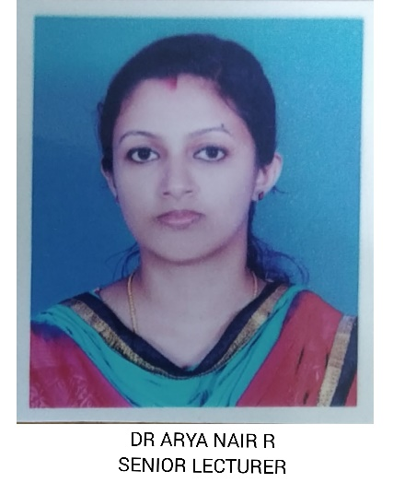**Name:** Dr Arya Nair R

**Qualification:** MDS Prosthodontics

**Designation**: Assistant Professor

**Additional Qualification:**

**Awards:**

1. Best paper at 1st IPS Midterm State Conference and Post Graduate Convention, Thiruvananthapuram, from 14- 15th October 2017

Topic- Rehabilitation of Maxillary and Mandibular Defects – A Case Report

**Achievement:**

**List of publications:**

1. Prosthetic rehabilitation of partially edentulous maxilla with precision attachment. Journal of IDA Attingal Branch, March 2019; 9(1), pp.32-34.
2. Biomaterials, Zirconia. In: StatPearls [Internet]. Treasure Island (FL): StatPearls Publishing; 2019 Jan-.
3. Surgical Stents - A Guide for Precise Implant Placement. Journal of IDA Attingal Branch, March 2019; 9(1), pp 11-14.
4. A Simplified Feeding Appliance for An Infant with Cleft Palate. Journal of IDA Attingal Branch, March 2018; 8(1), pp.33-35.
5. Telescopic denture - a case report. Journal of IDA Attingal Branch, March 2019; 9(1), pp. 29-31.
6. Maxillary obturator prosthesis for rehabilitation after maxillectomy: A clinical case series. Journal of IDA Attingal Branch, June 2018; 8(2), pp. 64- 66.
7. Candidiasis In: StatPearls [Internet]. Treasure Island (FL): StatPearls Publishing; 2020 Jan-.
8. Anatomy, head and neck, swallowing. In: StatPearls [Internet]. Treasure Island (FL): StatPearls Publishing; 2020 Jan-.
9. Prosthodontic significance of incisive papilla- an overview. Acta scientific dental sciences 5.6(2021)

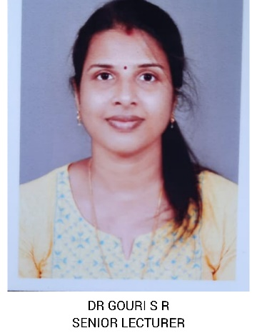**Name:** Dr Gouri S R

**Qualification:** MDS Prosthodontics

**Designation**: Assistant Professor

**Additional Qualification:**

**Awards:**

**Achievement:**

**List of publications:**

1. All on Four concept-revisited, Volume 1, Issue 1,December 2017,page 30-32

2. Implant Biomaterials- A Literature review, The journal of Prosthetic and Implant

Dentistry, Volume 2, Issue 1, September–December 2018, Page 39-45

3. A New Light on Prosthodontics- Enhancing Treatment Modalities With Lasers, IOSR

Journal of Dental and Medical Sciences (IOSR-JDMS),Volume 18, Issue 1 Ser. 19 (January.

2019), Page 86-90

4. Prosthodontics – can be enhanced with laser assistance???, The journal of Prosthetic and

Implant Dentistry, Volume 2, Issue 2, January–April 2019,Page 74-79

5. Prosthodontic Significance of Incisive Papilla - An Overview, Acta Scientific Dental

Sciences ,Volume 5, Issue 6, June 2021

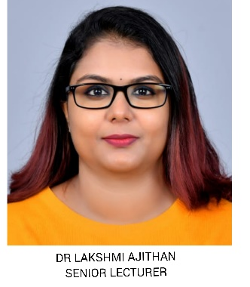**Name:** Dr Lakshmi Ajithan S

**Qualification:** MDS Prosthodontics

**Designation**: Assistant Professor

**Additional Qualification:**

**Awards:**

**Achievement:**

**List of publications:**

1. The Relevance of Polishing Acrylic Dentures - An Overview Acta Scientific Dental Sciences (ISSN: 2581-4893) Volume 5 Issue 5 May 2021

2. A Spick and Span Articulator: A Tee Off – Impression_Vol9-Issue2- June-2019

3. Prosthodontic Significance of Incisive Papilla - An Overview Acta Scientific Dental Sciences (ISSN: 2581-4893) Volume 5 Issue 6 June 2021

4. The Validity of Retromolar Pad as an Intraoral Landmark in the Fabrication of Complete Dentures - A Short Review Acta Scientific Dental Sciences (ISSN: 2581-4893) Volume 5 Issue 8 August 2021

5. All you need to know about CAD-CAM– Impression_Vol9- Issue1-March-2019